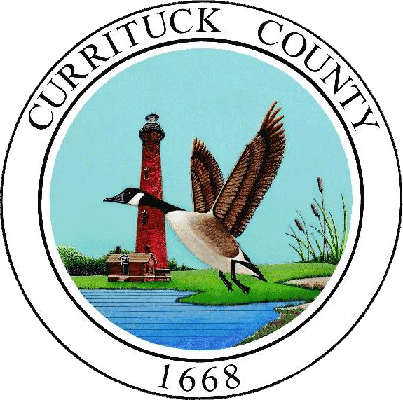

NOTICE TO BIDDERS
November 24, 2025
The County of Currituck, North Carolina (“the Owner”) REPLACEMENT OF FOUR VARIABLE FREQUENCY DRIVES AND CABINETS AT SOBWS located at Southern Outer Banks Water, 734 Ocean Trail, Corolla, North Carolina.
Bids will be received by email to Trischa Quinlan, Contracts and Purchasing Agent, at Bids@CurrituckCountyNC.gov until 5:00 p.m. Eastern Standard Time (EST) on December 23, 2025. Bids received after this deadline will not be accepted. It is the sole responsibility of the Bidder to ensure receipt of its’ bid by the County. Confirmation of receipt by telephone can be made directly to Trischa Quinlan at 252-232-6073.
Complete Contract Documents in digital (pdf) format for this project may be obtained from Trischa Quinlan, Contracts and Purchasing Agent, by email at Bids@CurrituckCountyNC.gov.
A non-mandatory Pre-Bid Meeting will be held on December 10, 2025 at 1:00 p.m. at 734 Ocean Trail, Corolla, North Carolina.
Questions and/or requests for clarification shall be submitted in writing to Trischa Quinlan, Contracts and Purchasing Agent by email to Bids@CurrituckCountyNC.gov no later than 5:00 p.m. on December 14, 2025.
All questions requiring additional information will be addressed in an addendum issued no less than (4) four days prior to the bid date. All addenda will be considered part of the Contract Documents.
This is an informal bid. Bids will not be opened publicly and read aloud. Award will be made to the lowest responsive, responsible bidder. No bid may be withdrawn after the scheduled closing time for the receipt of bids for a period of 30 days.
All bidders must meet the licensing requirements under Chapter 87 of the N.C. General Statutes. A General Contractor’s License will be required for this project. Small Business Entities, Women Owned Businesses, Minority Owned Businesses, Veteran and Service-disabled Veteran Owned Businesses are encouraged to submit bids.
The County reserves the right to reject any or all bids and to waive informalities and defects, as it may deem to be in its best interest.

